TITLE: Assignment Two [COACH BOOKING SYSTEM]

STUDENT 1: HEJA BIBANI, 16301173
STUDENT 2: MARCUS BELCASTRO, 19185398

DECLARATION: WE HERE BY DECLARE THAT THE WORK THAT IS PRESENTED IN THIS ASSIGNMENT HAS BEEN DONE WITH EQUAL SHARE OF WORK BETWEEN THE STUDENTS. THE WORK THAT HAS BEEN CONDUCTED IS TOTALLY OUR OWN WORK WHICH HAS NOT BEEN COPIED FROM ANY OTHER SOURCE OR PERSON.

Question 1
Practical 8:
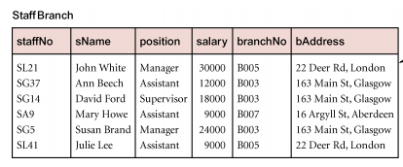

Relations with data redundancy suffer from update anomalies, which can be classified as insertion, deletion, and modification anomalies. This can be exhibited in the above diagram; a very simple Staff Branch relation which includes information about staff name, position, salary, branch and address of the Branch. We will assume that the database designed didn’t undertake the necessary steps of normalization, and kept the following data organized in the above relation as specified. In this case, if we were to delete StaffNo = ‘SA9’, we will also delete the corresponding entry of the BranchNo = B007 and its corresponding address. In this case, information regarding that particular branch will also be lost and this information will no longer be contained within the system. The deletion anomaly has been demonstrated in the following; and can be overcome with the process of normalization (decomposition); in this case, it would be more suitable to have two relations:
- Staff Relation
- Branch Relation

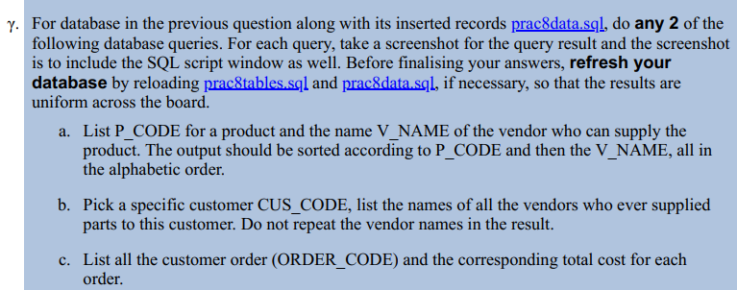
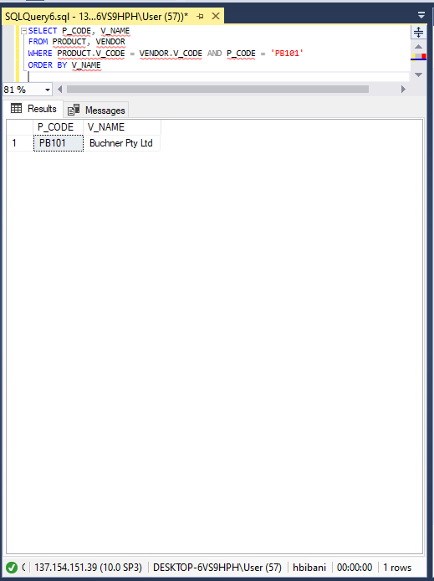
a.

B.
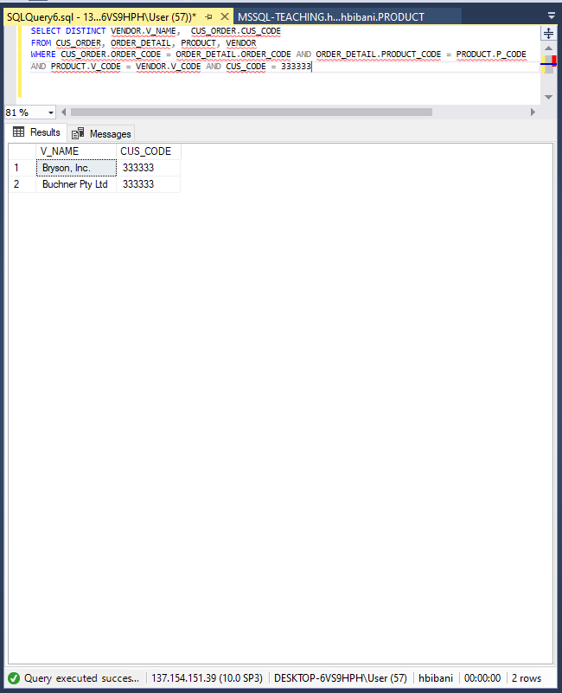

C.

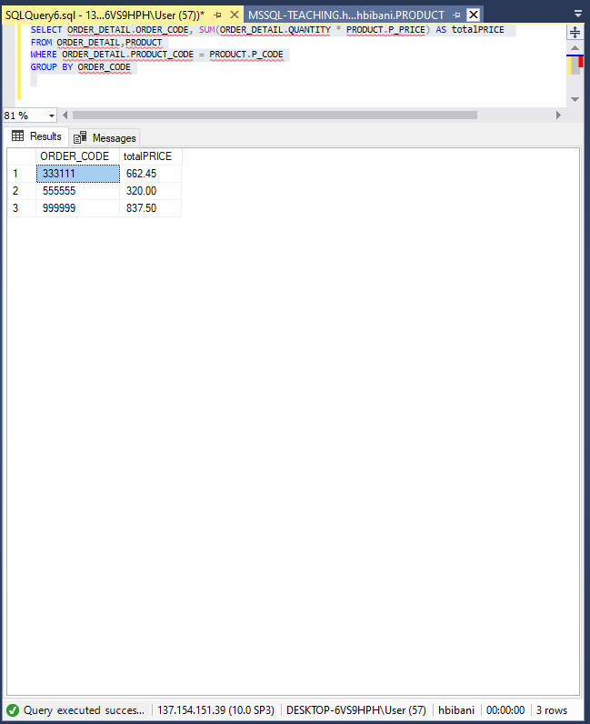

Practical 10:
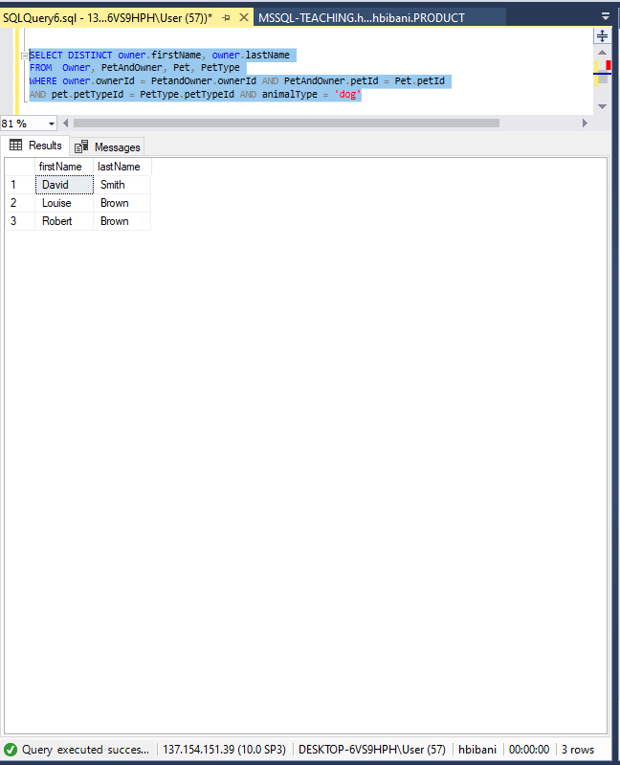

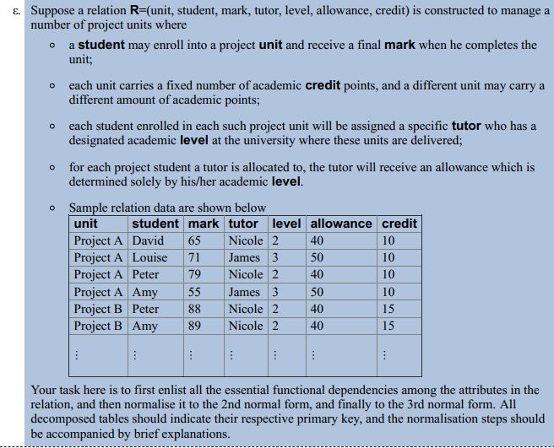
Functional Dependencies:
Unit, Student mark, Tutor, level, allowance, credit
2nd Normal Form:
There is a partial dependency which existed in the 1NF form above; and this is exhibited below; in this case the partial dependencies have been removed.
Unit Credit [partial dependency separated]
Unit, Student mark, tutor, level, allowance [partial dependency removed]
3rd Normal Form:
Transitive dependency exists on the relation “Unit, Student Tutor” AND
“tutor level and allowance”. We have made adjustments by separating the table and keeping the attribute of tutor in relation Student and Unit.
Unit Credit
Unit, Student mark, Tutor
Tutor Level, Allowance
Final Relations:
Unit Credit
Unit, Student mark, tutor
Tutor level, allowance
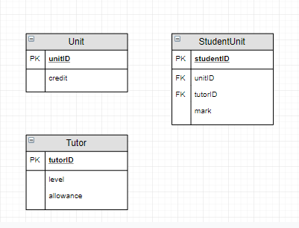

Practical 11:
- Atomicity
- Consistency
- Isolation
- Durability
Example:
Isolation: Transactions execute independently of one another. In other words, the partial effects of incomplete transactions should not be visible to other transactions.
Concurrency control is a concept of isolation, which allows multiple transactions to occur at one time without them interfering with each other. In this case, concurrency control fits within the framework of isolation, because it ensures that inconsistencies in the data are not produced because of update and read errors. In the same way we can meet the requirements of isolation by making the transactions occur serially (consecutively).
In an example, called lost update, we can speak about the case where two people are interacting with the same account:
- Transaction 1: withdrawing $10.00 from an account that has $100.00
- Transaction 2: depositing $100.00 into the same account.
Rationally (serially) the account should contain $190.00 at the end of both transactions. In the case with the lost update; we have a situation in which one transaction stores the update of $200.00; and the other transaction stores the value of $90.00 from the original. The second transaction only applies the change before the first transaction registers it (that means it uses the balance of $100.00 to modify). The first transaction saves the value that it had corresponding to the deduction of $10.00 from $100.00; and the program saves $90 at the end of the complete transaction. This value is not representative of the actual transaction in reality (doesn’t match the expected serial output of $190.00). We can solve this problem, by isolating both transactions by applying each transaction serially (using a lock mechanism). The lock mechanism doesn’t allow a second transaction to occur until the most recent transaction has been completed. Once the transaction commits, the second transaction can move forward. These two transactions will only occur one at a time; this will eliminate the inconsistency which has occurred during the two concurrent transactions. In this case, we will not allow transaction 2 to occur without transaction 1 being complete. This mechanism is a type of concurrency controls that demonstrates “Isolation” because it ensured that the transactions are executed independently from one another.

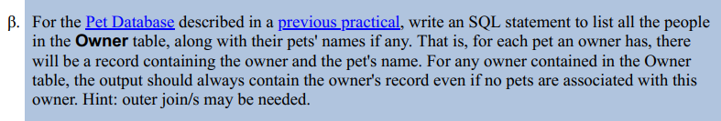
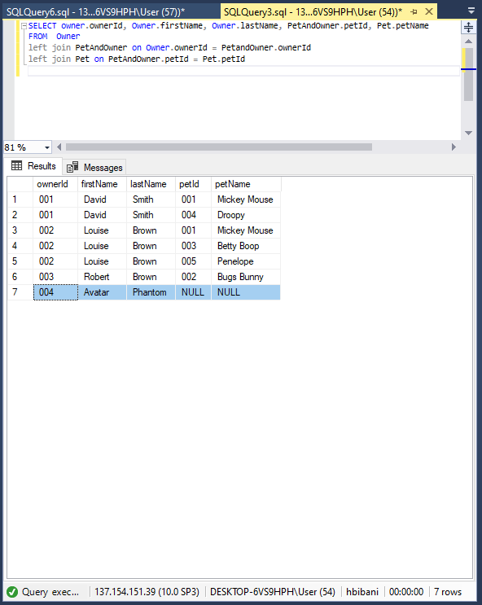

Question 2 [Diagrams]
Assumptions:
- A coach has multiple amounts of achievements [many-to-many]
- A coach has multiple expertise [many-to-many]
- A client can make more than 1 booking
- Client and Coach can negotiate a venue
- Training item consists of the coach + expertise with a venue
- Extra costs will be incurred by observing certain cost
Construction
The diagrams where produced in the following order:
- ER diagram
- Relation Diagram
Note: The text book explains that the relation diagram is absolutely necessary for the production of the GRD. We have produced the relation diagram, but we haven’t added it to this compilation because it was not explicitly stated.
- GRD
ER Diagram
The ER diagram does not match the logical structure of the actual database; and this was to be as expected. The constraints that the data has logically on the diagrams caused the GRD to be slightly different to the conceptual design. We followed a step by step process:
- Identify entities [nouns]
- Identify relationships[actions/verbs]
- Check for super classes
- Determine multiplicity
- Check for Redundancy between relationships
- Determine primary key
- Validate model against business rules

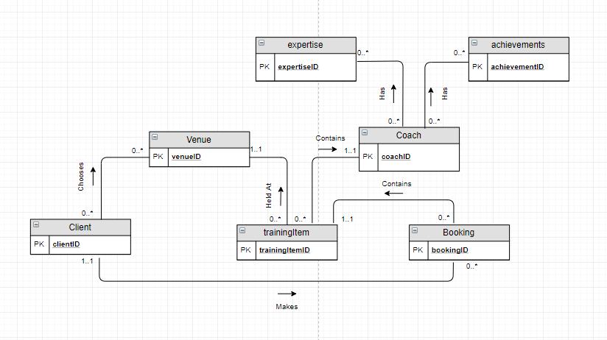
Note: We had several alternative diagrams; and these included ternary or quaternary relationships. In the previous assignment we had created the diagram based on the relationship types. Although that it may look very nice to implement, it wasn’t without its problems, it made it difficult for us to turn it into the relational/GR diagrams. In this case, we have decided to avoid using this in this context, and have found that keeping booking as more directive entity in the diagram was beneficial for the creation of the secondary diagrams. Studying the lectures we had noticed that the lecturer had employed this particular methodology to produce a diagram for a case study on projects and dig sites (one that avoided relationship types).
Logical/GRD Diagram
The logical diagram followed the same fundamental iterative process that is requested from us in the lecture notes. In this case, we used this step to determine:
- The attributes
- Determine the domains for those attributes
- Produce new entities based on many-to-many relationships
- Identify parent-child relations
- Determine logical multiplicity
- Produce new relations for many-to-many relationships
- Check for Duplication
- Check for Redundancy
- Identify Foreign Keys and Integrity Constraints

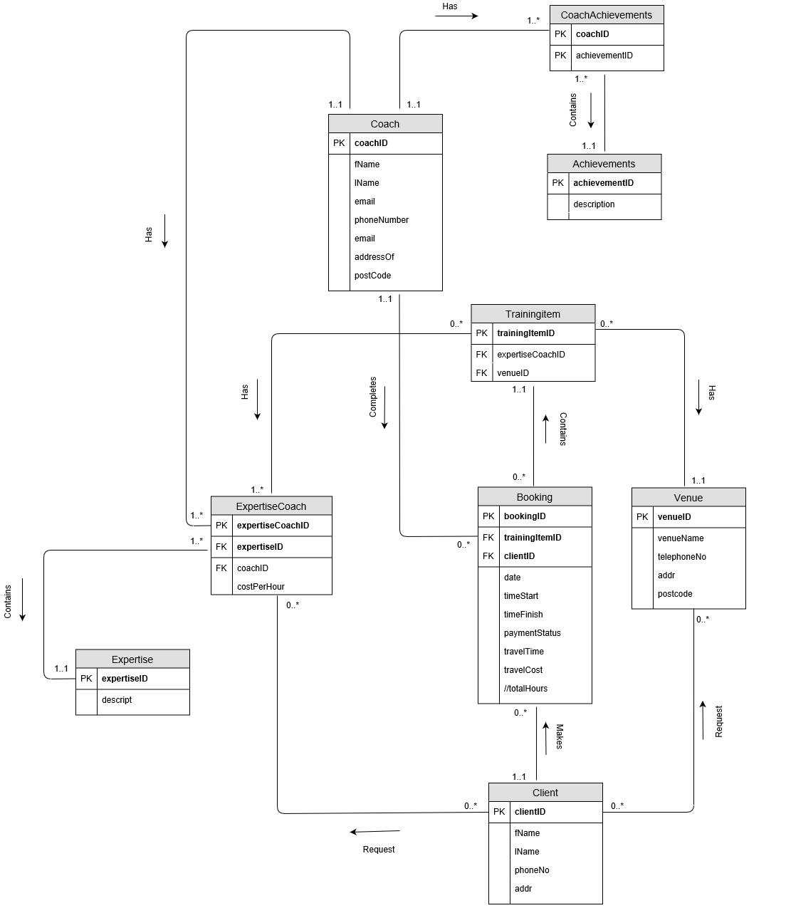

Question 3 [SQL]
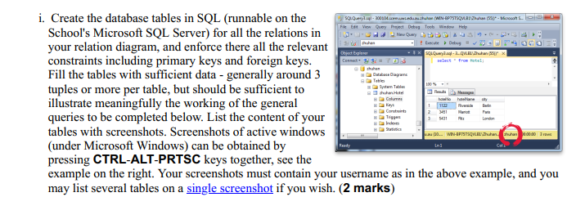

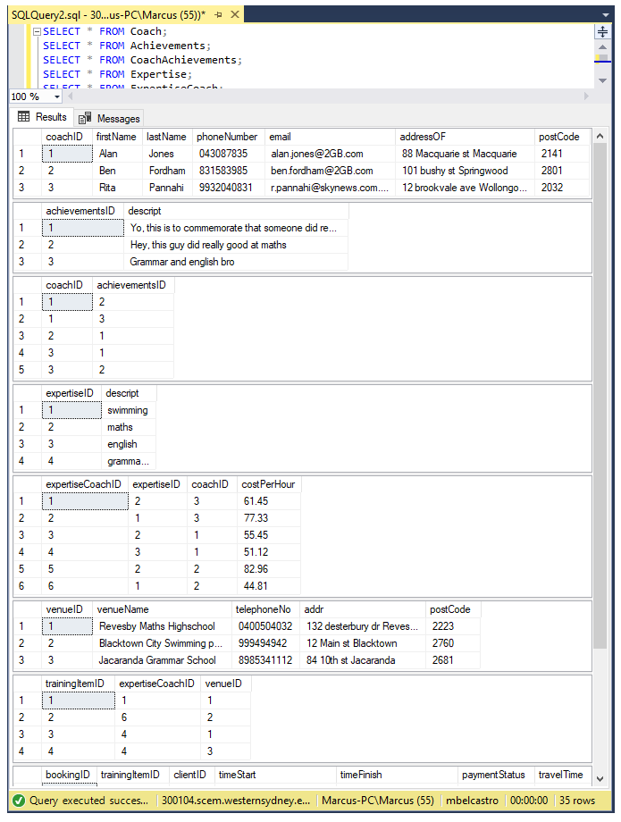

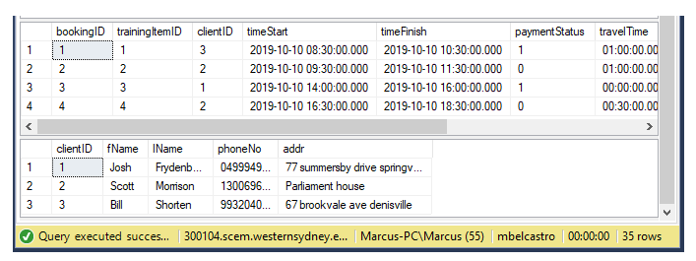

NOTE: There is a view in the database that implements a derived field(_BOOKING_V); and this used to determine the total hours. We have also implemented a system in such way to derive the total cost by using a select statement at the time of payment.
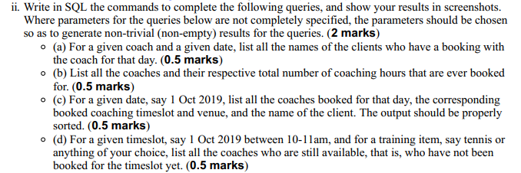

(A)
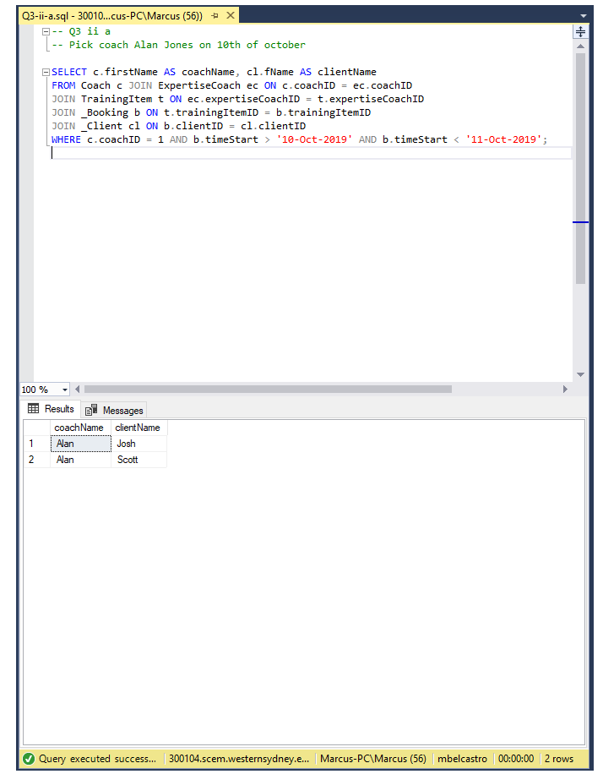

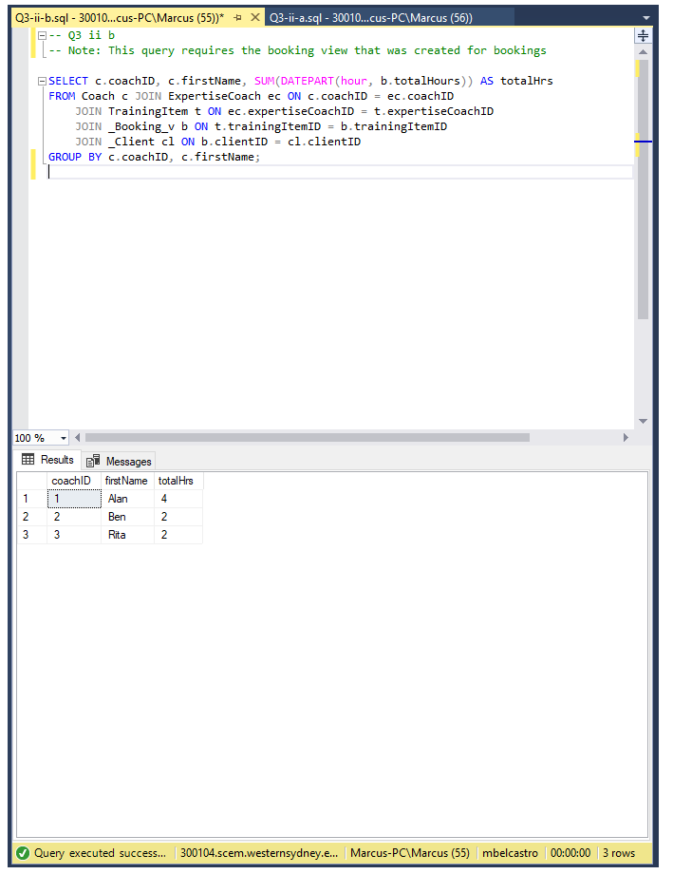
(B)

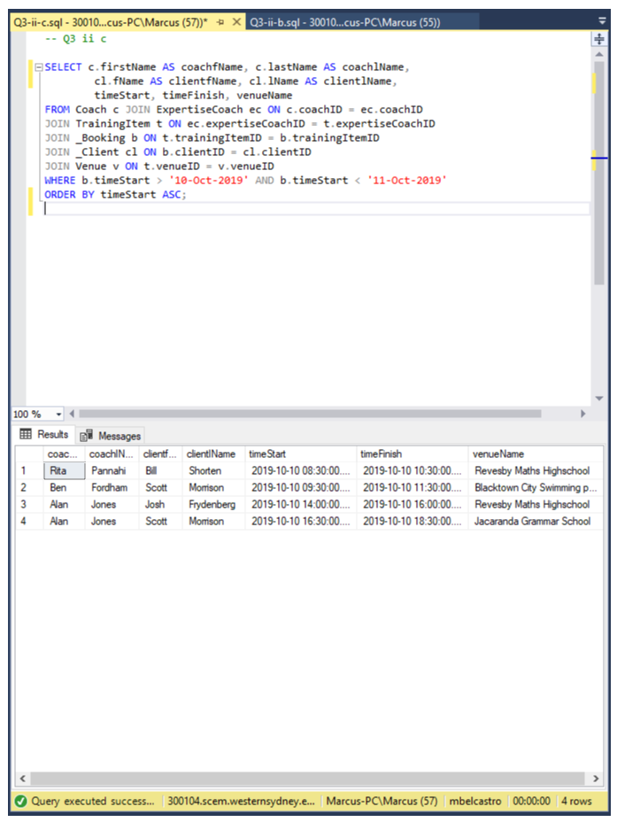
(C)

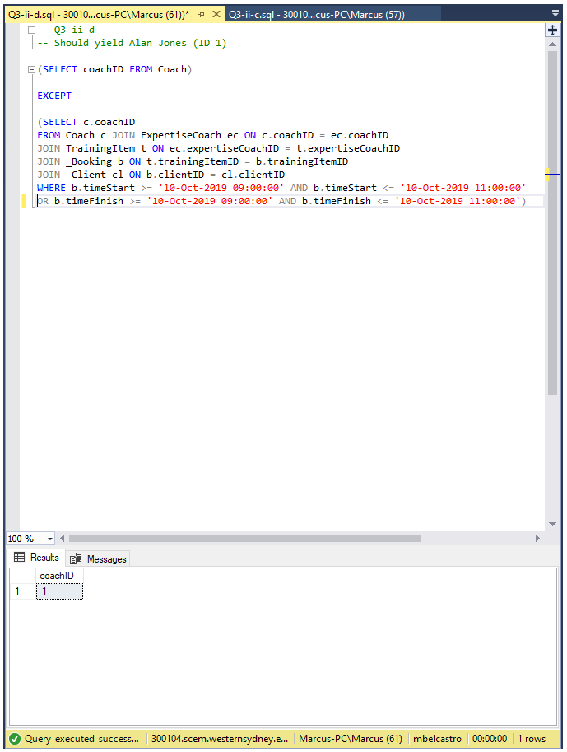
(D)

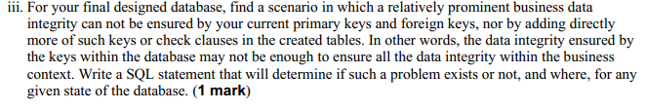
-- Q3 iii
-- This query will test whether the same client can book the same training item at the same time.
-- This takes advantage of the fact that bookingID is included in the composite primary key.
INSERT INTO _Booking VALUES (111, 1, 1, '10-10-2019 09:00:00', '10-10-2019 19:00:00', 0, '09:00:00', 0.0);
INSERT INTO _Booking VALUES (112, 1, 1, '10-10-2019 09:00:00', '10-10-2019 19:00:00', 0, '09:00:00', 0.0);

-- Using the same technique as above, let's try and make the same coach be an expert in the same thing twice
INSERT INTO ExpertiseCoach VALUES (111, 1, 1, 61.45);
INSERT INTO ExpertiseCoach VALUES (112, 1, 1, 24.22);

